2013 Year end ministry update
Dear
2013 has been a year of many wonderful opportunities to minister In Jesus name. Our focus continues to be helping men see the value of living a lifestyle of investing in a few men’s lives in intentional discipleship relationships. The dynamic of small group (3) discipleship is proving to be the life transforming environment we have hoped it would be. We are presently providing leadership in 5 discipleship groups.
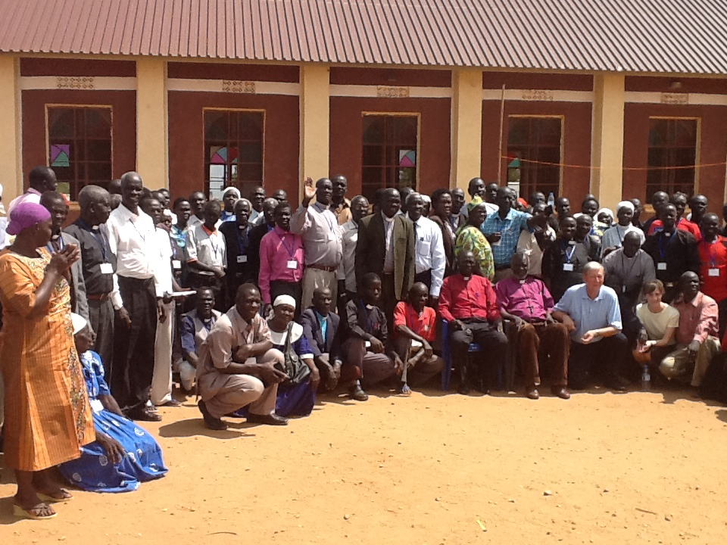
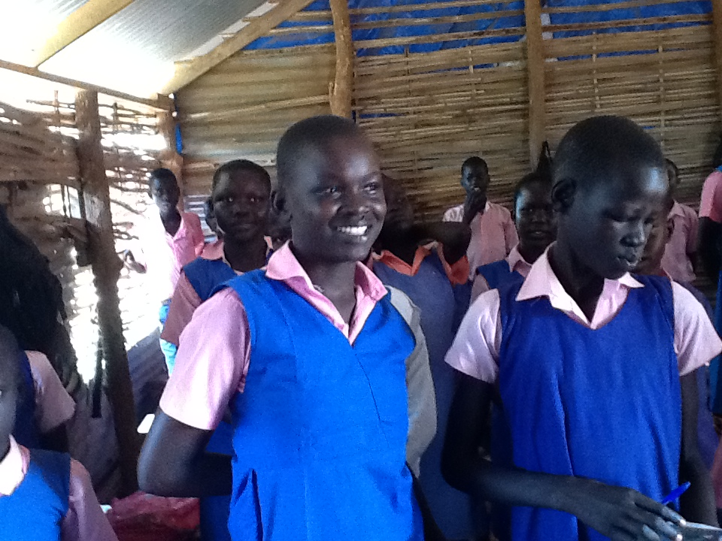
We continue to work with Sudanese Pastor Robert Lobung who pastors the Ambassadors of Christ Church here in Jacksonville. For some time Robert and I had been in prayer and discussions about going to his home in Juba, South Sudan for the purpose of building up the church through teaching discipleship and visiting a school for “at risk children.” The Lord arranged for us to receive an invitation from Diocesan Bishop Enock Tombe Stephen of the Episcopal Church of the Sudan to participate in their Pastors Leadership Conference. Robert, Carol Corn and I were invited and given subjects about which the pastors wished to hear. Robert was to speak on giving, Carol on women in ministry and I on unity in the church and discipleship. There were an estimated 125 pastors that attended. See if you can pick Carol and me out of the group picture☺
Other opportunities during the visit included:
- Delivery of the Jesus film equipment to the CRU staff and visiting with students active in CRU on the Juba University campus.
- A visit to a children’s hospital where in 5 wards we were able to pray for the children, moms and staff.
- A visit to World Visions headquarters where we met director Perry Mansfield and his staff which was very educational regarding life conditions in the country.
- Meeting Robert’s family and friends that allowed us to understand what life is truly like in South Sudan.
It would take much more time to share all that we experienced while in South Sudan suffice it to say it was a very worthwhile trip.
In addition we continue to serve with First Coast Women’s Services as a counselor with the men who accompany the ladies who come to the pregnancy center. These encounters almost always provide opportunity to share a clear explanation of the gospel. It represents the most significant opportunity for evangelism in our ministry
We have been asked by a new church plant, The District Church, to provide help in establishing an intentional discipleship ministry within the church. This is an exciting opportunity. We have also been asked to serve as the coordinator of the life on life discipleship ministry in my home church Christian Family Chapel. As you can see there is no lack of opportunity for ministry. We very much need your prayers to know what to accept and how to proceed.
The new opportunities are exciting and evidence the growing credibility of what we are doing, at the same time there are increasing financial needs. All of the expenses in doing ministry are increasing and home maintenance issues should not be ignored any longer. We are aware that some of you learn more specifically what you are able to give as your year-end approaches. Would you prayerfully consider In Christ Ministries in your giving to Christ’s work? We pray each of you would be willing to pray for this work and give financially as God would lead you.
Let us continue to be encouraged to faith and good works knowing how greatly God delights in us,
“The Lord your God is in your midst,
A victorious warrior.
He will exult over you with joy,
He will be quiet in His love,
He will rejoice over you with shouts of joy.” __ Zephaniah 3:17

In Christ,

Cortez Ragland

